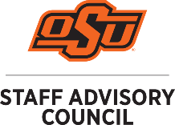
Staff Advisory Council Agenda
Staff Advisory Council will meet on
September 8, 2021 @ 1:15pm
416 Student Union Case Study 2 and via Zoom
All meetings are open to the public.

- Call to Order: Melanie Bayles
- Roll Call: Michelle Stewart
- Approval of the Minutes: Melanie Bayles
- Approval of the Agenda: Melanie Bayles
- Special Guest Speaker: Joe Weaver
- Officer Reports:
  - Treasurer’s Report: Tammy Ratcliff
  - Secretary: Michelle Stewart
  - Vice-Chair: Kristi Wheeler

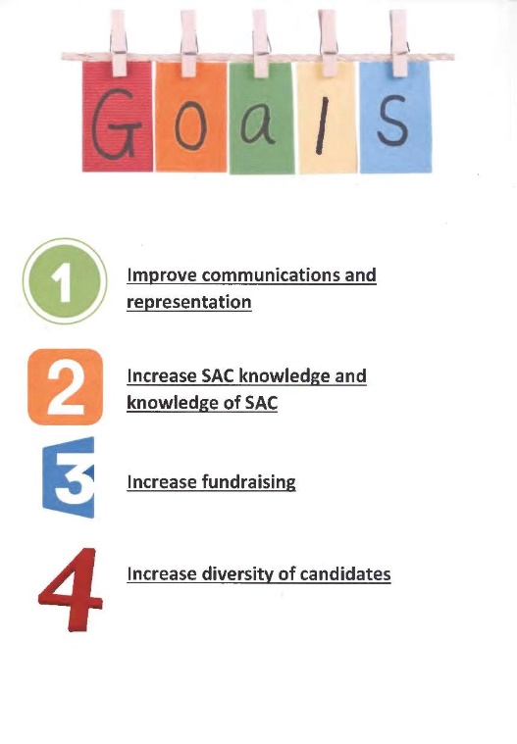
- Chair: Melanie Bayles Meetings of Standing Committees:
  - Rules, Policy and Procedures: Chris Pivinski
  - Communications Committee: Gary Lawson
  - Awards and Recognition Committee: Ashleigh Hall
  - Events Committee: Michelle Chitwood
  - Diversity, Equity & Inclusion Committee: Cara Eubanks

- Branch Campus Reports:
  - OSU-Tulsa: Olivia Woody
  - OSU -CHS: Sherrita Sweet
  - OSU-OKC: Dezzarae Francis
  - OSUIT-Okmulgee: Na-komas Blackford
- Reports of University Committees:
  - Faculty Council- Melanie Bayles
  - Human Resources- Christa Louthan
  - GPSGA: Megan Ruby and/or Marcia Sun
  - Department of Wellness: Kim Beard
- Unfinished Business:
  - RPP bylaw update proposal- please see attached.

- New Business:
- Announcements:
Next Meeting – October 13, 2021 1:15 PM 416 Case Study 2 Student Union (also available via Zoom)

- Adjournment

